SPAM DETECTION APPLICATION

*Wireframe documentation*

|  |  |
| --- | --- |
| Written by | Sarthak Bathla, Srishti Gupta |
| Last revised date | 28-2-24 |

Home page

First thing anyone will see is the homepage.

It contains the header as “SPAM DETECTION APP”

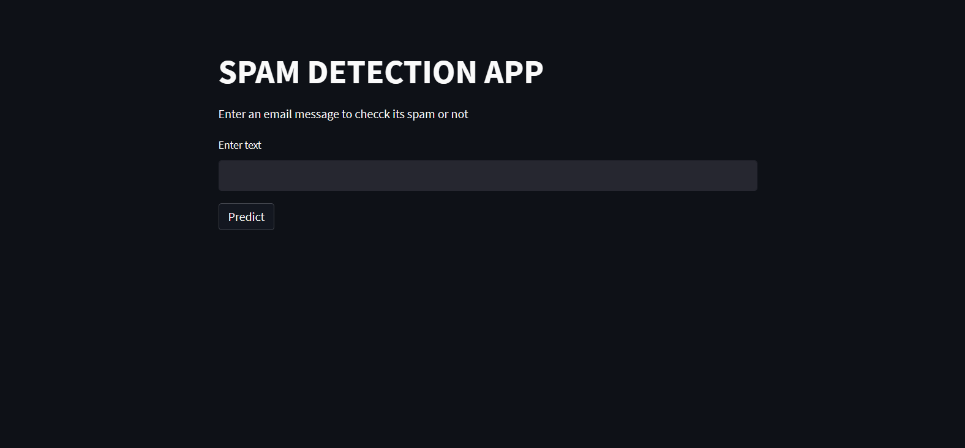

User has to input the mail body

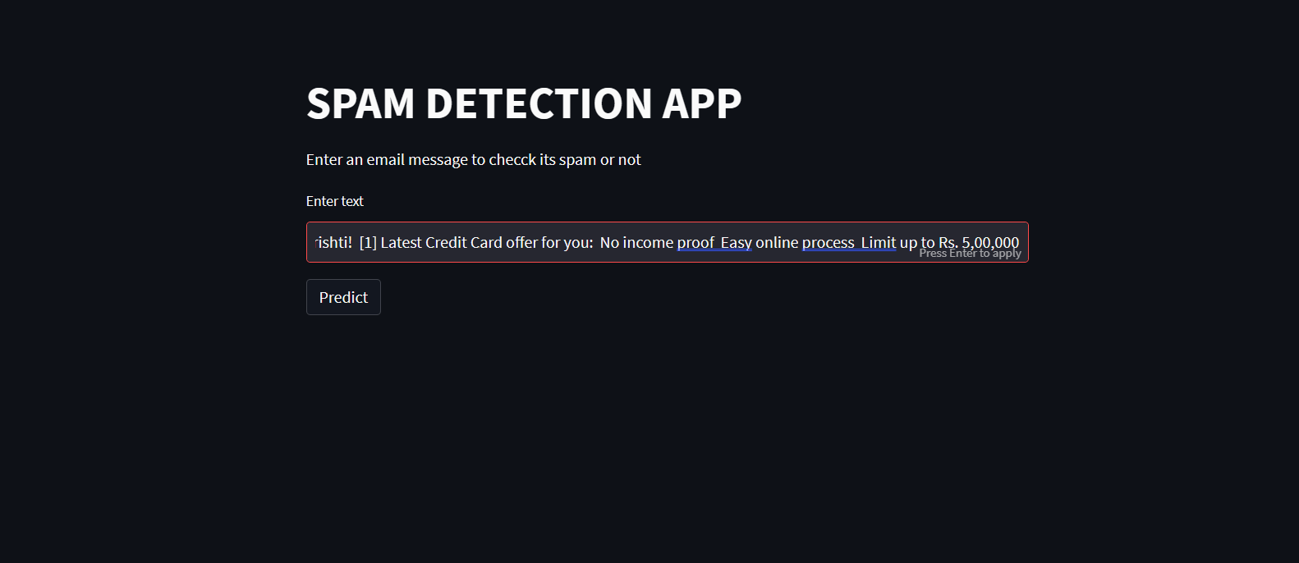

User will click on the predict button and the output will be displayed.

